The structure is created using the struct keyword and the required variables are declared inside the structure. Typedef keyword has been used to create the structure. The typedef is a keyword used in C programming to provide some meaningful names to the already existing variable in the C program.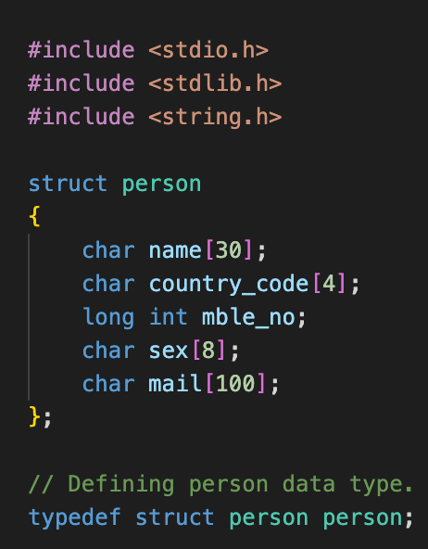

Since we have will be using functions in our C project, all. The required functions are declared.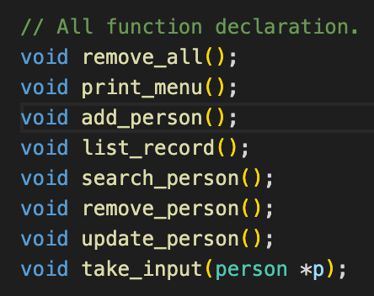

The start function is created where the user is given the list of choices of things that he can perform in the phone book like to add a person, update contact details, etc and as the user inputs the choice the corresponding function gets executed.

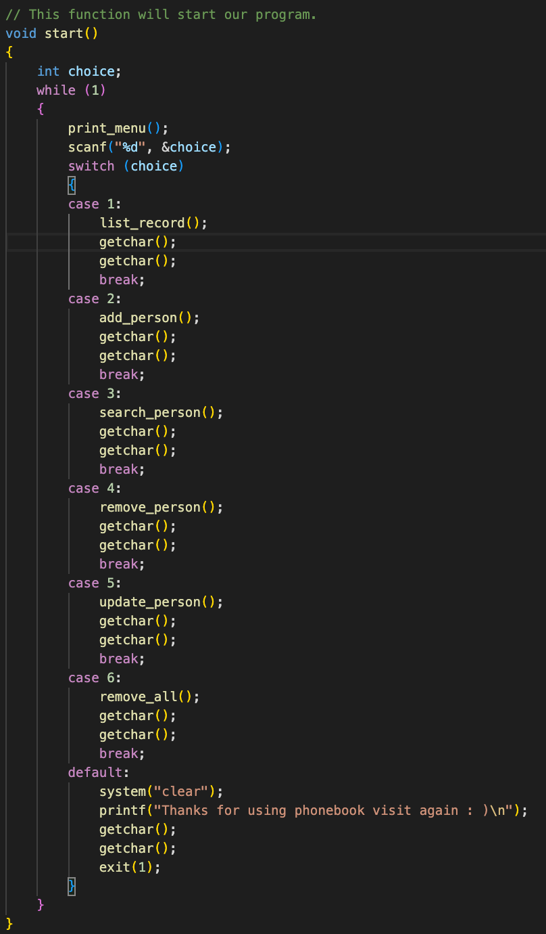

At the start of the main program the start function is called to display the list of choices.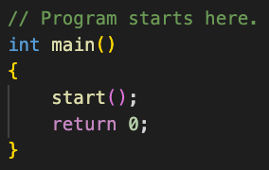

The phone book application is been made under the concepts of functions and file handling.

The following things can be done in the phone book application :

1. List Record.
2. Add Person.
3. Search Person Details.
4. Remove Person.
5. Update Person.
6. Delete all Contacts.
7. Exit Phonebook.

For example if the user selects the add person option the function corresponding to it will be executed and the file in which the data will be stored will also be opened and the user will be asked to input the following details.

* Name
* Country Code
* Mobile Number
* Gender
* E-mail address

If the file fails to open it will throw an error saying “Error in file opening, Plz try again”.

Similarly the application works for all other choices.

Output :

* Add Person :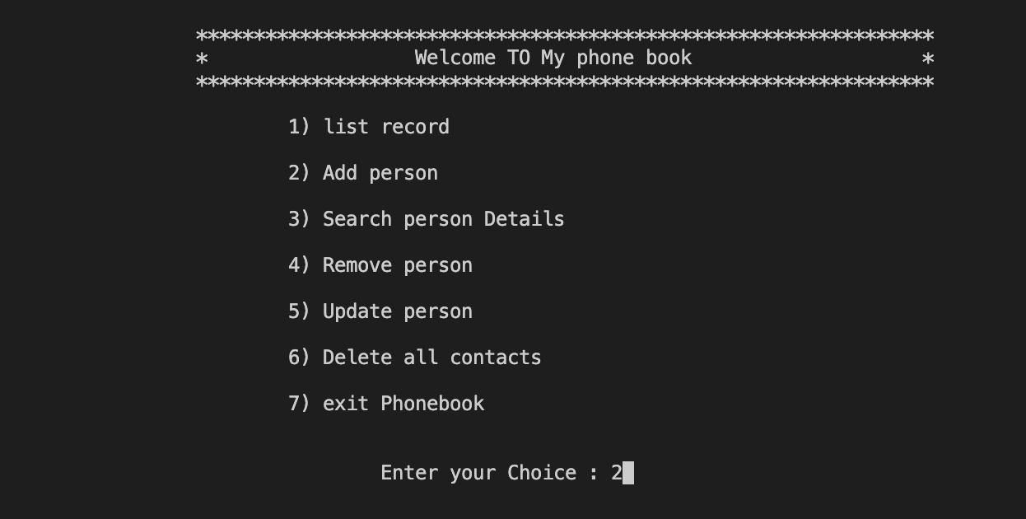

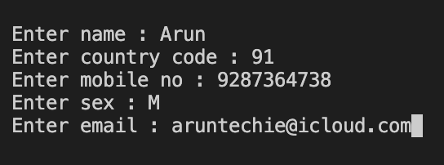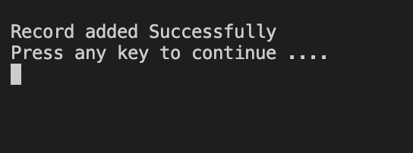

* List Record :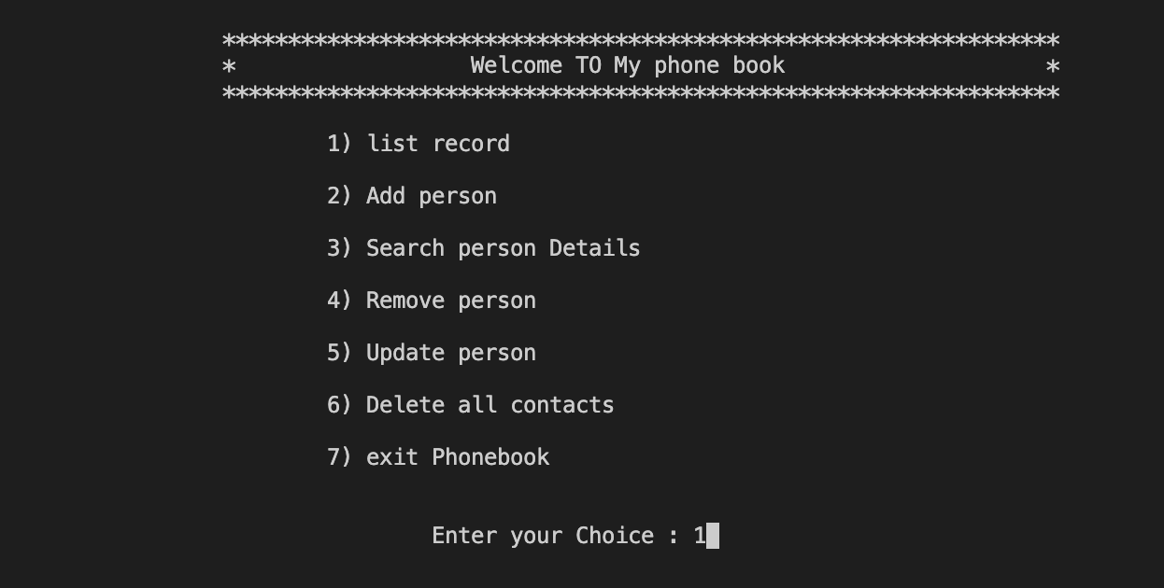

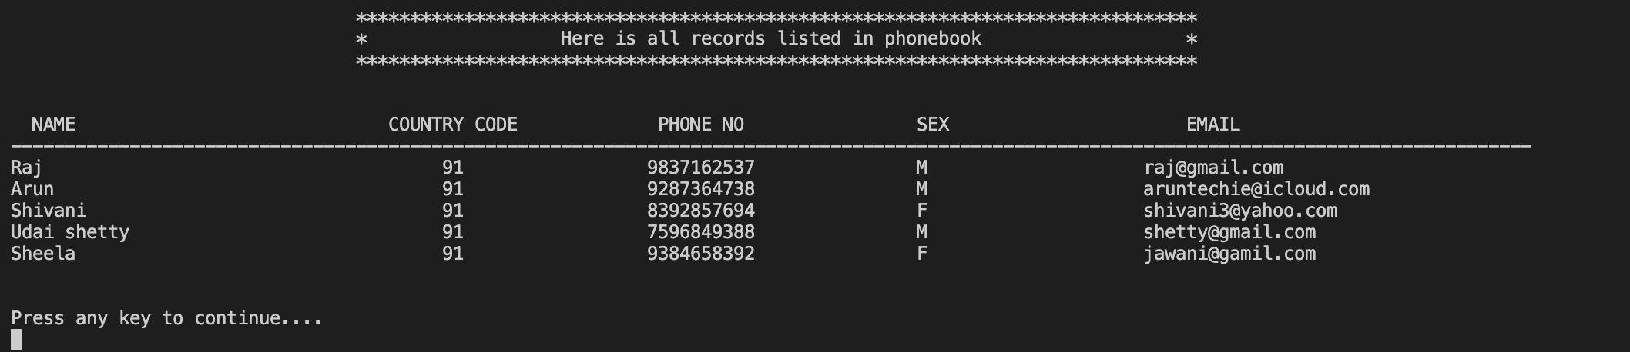

* Search Person Details :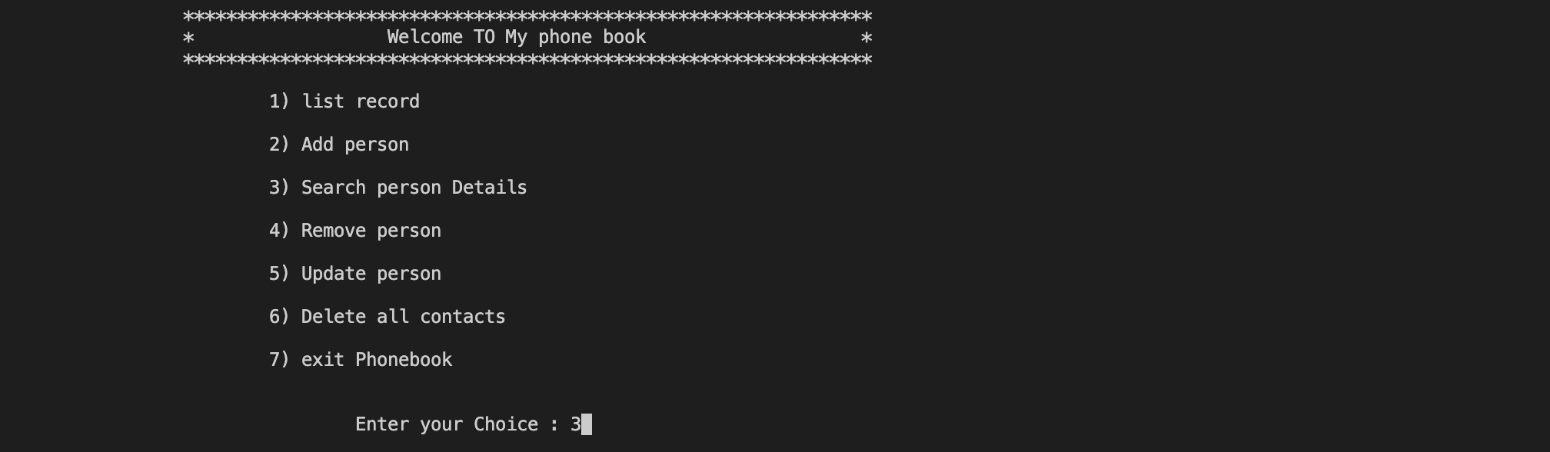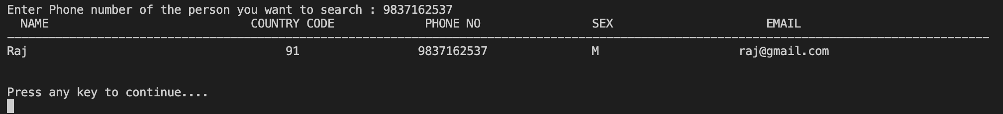
* Update Person :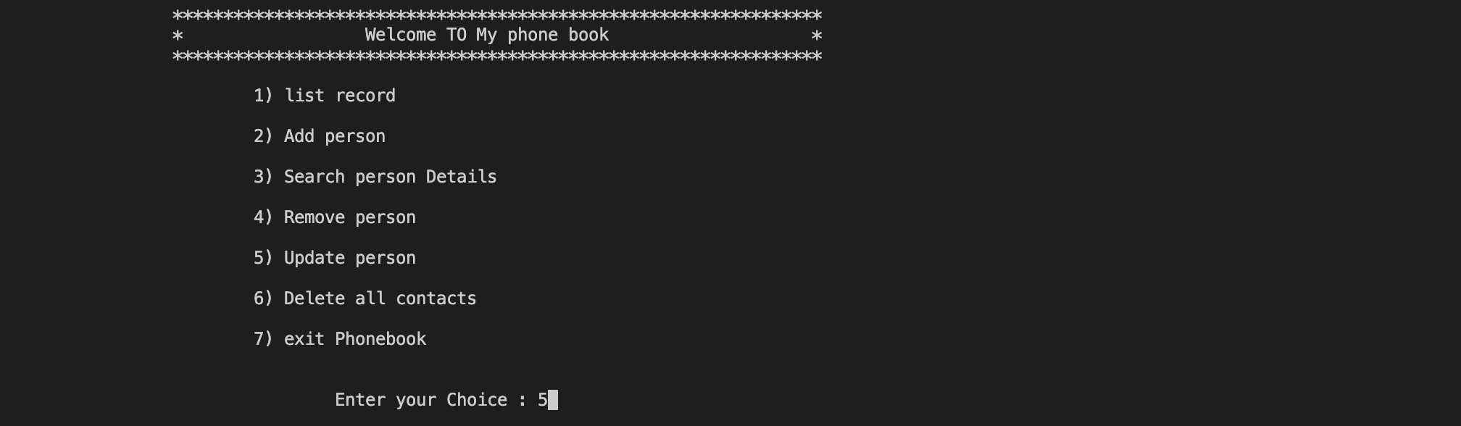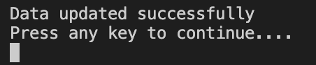
* Remove Person :Image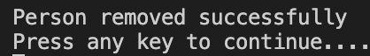
* De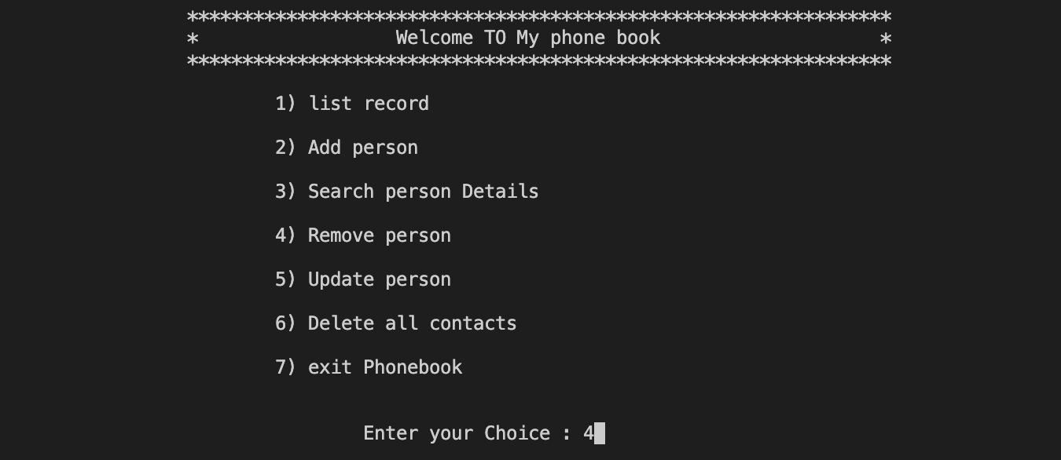lete all Contacts :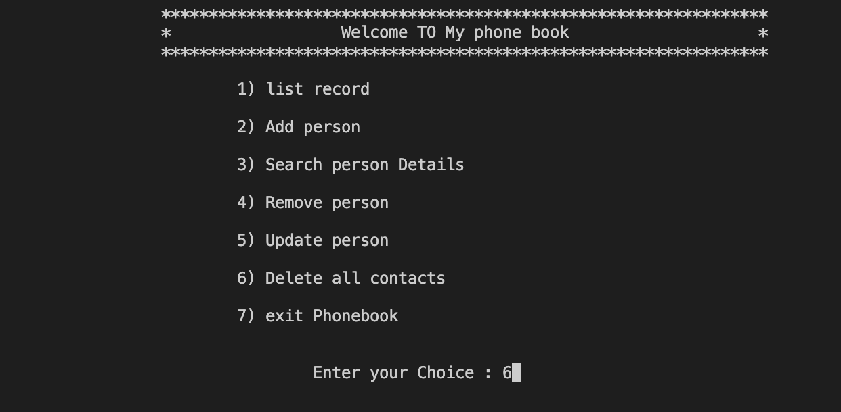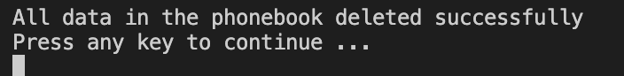
* Exit Phonebook :